Fixed Assets
Fixed assets are assets intended for long-term use, that aren’t expected to be quickly converted into cash. They include things like property and equipment.
Over its useful life, a fixed asset loses its value due to wear and tear, depletion and the passage of time. Because of this, the K-State Student Union depreciates fixed assets in order to know the actual value of the asset. The Union uses the straight-line depreciation method. To calculate depreciation of an expense, the Union takes the total cost of the fixed asset and divides it by its useful life. To find the current value of the asset, subtract the accumulated depreciation expense from the original cost. The straight-line method spreads out the cost of the asset over its useful life, rather than taking a financial hit in the year the asset was purchased.
The Union records assets valued at $2,500 or more. Depreciation is calculated monthly. When a department turns in an invoice, the code to use is 1610 for equipment and furniture and 1620 for leasehold improvements. The invoice should include the department name, asset(s) name, estimated useful life (5 yrs.,10 yrs. or longer) and serial numbers. The Specialist II/Accounting will create an asset tag with an assigned asset number. The tag is then affixed to the asset. Assets valued under $2,500 are expensed out immediately. The Specialist II/Accounting will provide a “Property of K-State Union” sticker upon request.
Disposing of Assets
There are two main ways to dispose of a fixed asset. It can either run the course of its useful life, or the Union could sell or dispose of the asset. If the asset lasts through its useful life, the department may replace it with a new one or sell it. The department head should complete a Disposition of Fixed Assets Form and provide it to the Specialist II/Accounting so the asset can be removed from the books. When possible, turn in the asset tag when turning in the completed Disposition of Fixed Assets Form. The form can be found in the Union’s staff center.
Disposition of Fixed Assets Form Sample –
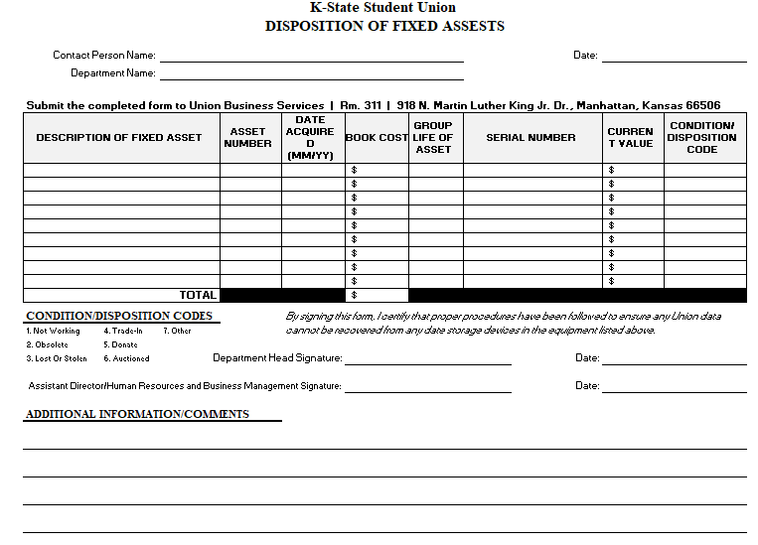
Transferring Assets
If a department transfers or relocates its asset(s) to different department, a department head should complete a Transfer of Fixed Assets Form and return it to the Specialist II/Accounting.
Transfer of Fixed Assets Form Sample –
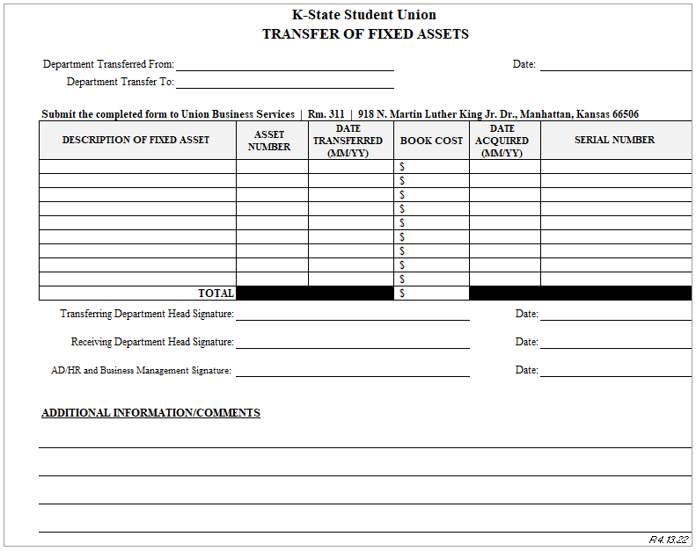
Assets and Budget Preparation
During the budget planning period, the Specialist II/Accounting will email department heads the department’s Assets List and Future Depreciation Reports. Departments physically locate and confirm each asset’s location. If there are any changes, the department head will fill out the Disposition of Fixed Assets Form or the Transfer of Fixed Assets Form and return the form(s) to the Specialist II/Accounting.

